Contents
1 HOUSEHOLD TRAVEL SURVEY 1
2 BASELINE HEALTH BURDEN 5
3 HEALTH IMPACT CALCULATIONS 7
3.1 Health Impact Estimates 7
3.2 Health impacts of PM2.5 pollution 7
3.3 Health impacts of travel physical activity 8
3.4 Integrated Injury and Physical Activity Model 9
3.5 PM_{2.5} Dispersion Modelling 14
3.5.1 Multi-Pollutant Emission Inventory 17
3.5.2 Spatial Distribution and Sector-specific Shares of PM_{2.5} Concentrations 19
4 UNCERTAINTY ANALYSIS OF HEALTH BURDEN ESTIMATES 22

HOUSEHOLD TRAVEL SURVEY
A travel-diary door-to-door survey of a sample of households in Delhi was conducted from February through August 2013. The survey was conducted as a part of this dissertation work, and the design of survey questionnaire, development of sampling strategy, training and coordination of survey team, phone calls to households to confirm legibility of completed questionnaires as well as to ascertain missing or confusing data, and cleaning of datasets were carried out solely by the author. For carrying out surveys in the sampled households, a team of private marketing agency was hired and trained by the author through mock surveys within the institute as well as trial surveys at the sampled localities, and each individual in the team was trained separately. During the surveys, the team was coordinated by a team leader from the hired agency and by the author. The survey was conducted in Hindi language which is the local language of Delhi.
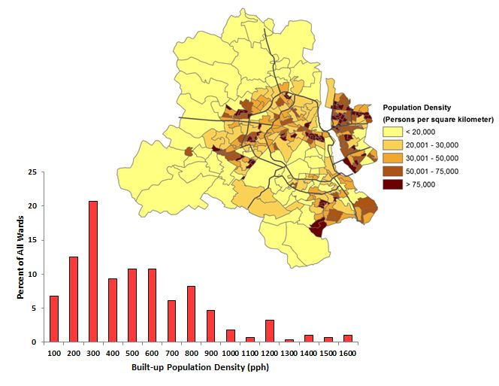
Figure 1: Ward-level population density in Delhi
To sample households, two-stage stratified random sampling was used. In the absence of any sampling frame, city was divided into equal size grids which were then sampled in the first state. To create grids, Google Earth (GE) imagery of Delhi was used to identify built-up area for 2012. The total identified built-up area is approximately 623 km², which is less than half of the area within the official boundary of Delhi (1483 km²). This results in a built-up population density of 26,800 persons per km² or 268 persons per hectare (pph). To put this in perspective, this is much higher than other major cities in high-income countries (~5 times of London, 4 times of Paris and ~12 times of New York, Angel et al., 2010).
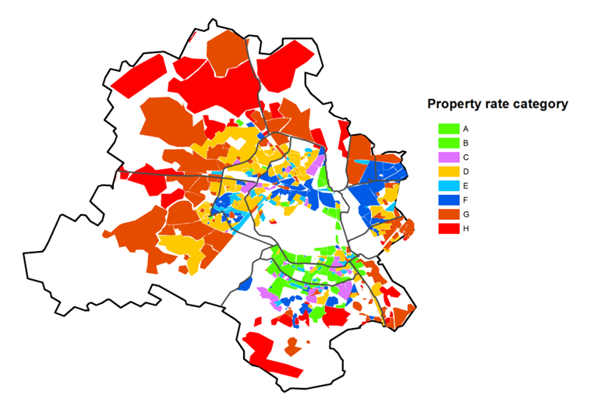
Figure 2: Property rate categories for localities in Delhi
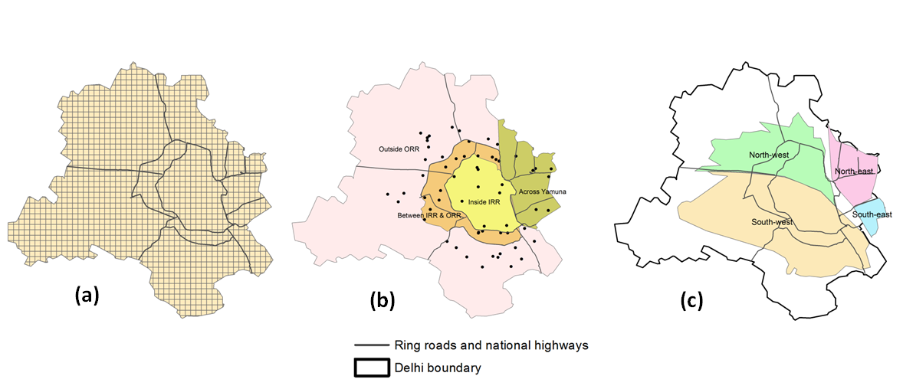
Figure 3: (a) 1km × 1km grids; (b) Area in Delhi divided into Inside Inner ring road (IRR), Between IRR and Outside Ring Road (ORR), Outside ORR, and Across River Yamuna along with sampled localities; (c) Area in Delhi divided into four quadrants – North-west, South-west, North-east and South-east
Delhi is divided into 282 wards (administrative divisions), out of which 272 fall under the jurisdiction of MCD. The average size of wards is 4.9 km², with more than half (54%) of all the wards having an area of less than 2 km². For GIS analysis, QGIS (version 1.8.0) was used, which is an open source Geographical Information System (GIS) platform. A GIS shapefile was used with wards of Delhi and their corresponding population for Census 2011. By overlaying this shapefile on built-up area of the city, population of each ward was allocated to its corresponding built-up area, in order to obtain a high-resolution spatial distribution of population. The average and median built-up population densities of all wards in Delhi are 490 pph and 230 pph, respectively, with 60% of the wards within 500 pph and 85% within 800 pph (see Figure 1).
A grid map with a resolution of 1km×1km was superimposed over the resulting shapefile of built-up in each ward, (see Figure 3), and the population was interpolated for each of the grids from the ward-level population. These grids provide a sampling frame from which the first stage sampling can be done. In Delhi, residential areas are divided into localities (colloquially called as colonies), which are homogeneous groups of houses. There are a total of 2334 localities within MCD’s jurisdiction. For property tax collection from residential areas, MCD has categorized each locality under eight different categories of property rates referred to by the letters ‘A’ through ‘H’, commonly known as circle rates, which are derived from the current cost of land per m², with A being the highest property rate and H being the lowest (see Table 1). From the online portal of MCD, map-based database for localities, and their respective property rate categories, was used. Using this database, along with GE, a shapefile was created for the property rate category map (see Figure 2). Each locality was then allocated to one of the grids shown in Figure 3. Note that one locality can simultaneously be mapped to more than one grid.
Table 1: Property rate categories of localities under MCD jurisdiction
Category | Circle Rate  (Indian Rupees – INR – per m²)
A | 6,45,000
B | 2,04,600
C | 1,33,220
D | 1,06,390
E | 58,370
F | 47,140
G | 38,440
H | 19,360
Further, stratification of these grids was carried out based on three criteria— a) location of grids with respect to ring roads (within inner ring road, between inner and outer ring roads, and outside outer ring road (including across Yamuna river), b) location of grids with respect to the four quadrants in Delhi (north-east, north-west, south-east, and south-west, and c) categories of circle rates, with A and B combined into one and E and F combined into other (A-B, C, D, E-F, G, and H) (see Figure 3). Based on these three criteria, a total of 72 strata were obtained, among which only 42 were feasible. For instance, there was no grid with A/B circle rate category outside outer ring road and in the north-east quadrant. Using gridded population, population for each stratum was calculated.
To obtain a sample of ~2000 households, 70 grids were randomly selected from all the strata with the number of grids sampled from each stratum proportional to the latter’s population. Among the selected grids, for those with more than one locality inside them, the locality with the largest area within the grid was selected. Further, in the second stage of sampling, 30 households were randomly selected from each of the selected localities while visiting the site. For household selection, every 10th household was selected, walking by right-hand rule in which the next house selected was to the right of the interviewer. The average response rate was 65%, with significant variation across the localities.
In the survey questionnaire, travel diaries were recorded of all the residents of the household for the day previous to when visited the houses were visited for the survey. The surveys were conducted from Tuesday through Saturday to capture weekday travel pattern from Monday through Friday. For trips which included more than one segment, the questionnaire included segment-wise break-up of the trips. For instance, in case of a public transport (PT) trip, there are at least three segments— a) from home to PT stop, b) PT stop to destination bus stop, and c) from PT stop to final destination. In case of a transfer, the segments will be even more. The survey also consisted of demographic and socio-economic characteristics of the household as well as individuals. For these, the questionnaire included questions which were similar to those in the Census. The trip lengths were reported by survey respondents and were rechecked using Google Maps to detect major discrepancies. In the questionnaire, the telephone numbers of the respondent’s household were also asked. The contact numbers were used while cleaning the data, to contact the respondents to clarify on some of the data gap or inconsistency in the questionnaire.
Table 2: Household characteristics— Sample versus Census
 | Sample | Census
Household size
1 | 7% | 4%
2 | 9% | 8%
3 | 20% | 13%
4 | 31% | 24%
5 | 18% | 20%
6-8 | 13% | 26%
9+ | 2% | 6%
All | 100% | 100%
Vehicle Ownership
At least one car | 29% | 22%
At least one 2W | 64% | 41%
At least one cycle | 23% | 29%
No vehicle | 19% | 36%
All | 100% | 100%
House Ownership
Own | 61% | 68%
Rented | 27% | 28%
Other | 12% | 4%
All | 100% | 100%
After data cleaning, travel diaries from 70 localities and 1711 households (6844 individuals) were used. Table 2 presents a comparison of three household variables for the sampled households and the census conducted in 2011 (Census-India, 2012). The sample has an overrepresentation of households with 5 or fewer members, and those owning vehicles. To obtain a representative data for the whole population, post-stratification weights were estimated. For this, one-way table of percentage distribution of households classified by vehicle ownership and two-way table of categories of house ownership and size of household, from Census data of Delhi were used. For obtaining weights, iterative proportional fitting was used, which uses an iterative procedure in which the convergence is reached when the marginal distributions of the three variables (vehicle ownership, house ownership and number of members in a household) of the sampled population are almost the same as that of Census. The weights achieved for households were assumed same for all the constituent members.

BASELINE HEALTH BURDEN
We used Indian GBD online tool (https://vizhub.healthdata.org/gbd-compare/india) for the baseline health burden of Delhi for year 2014. Table 3 shows age-specific deaths and DALYs for traffic injuries and disease end-points modelled through PM_{2.5} pollution and Table 4 presents gender-stratified burden of disease end-points modelled through physical activity.
Table 3: Deaths and DALYs for PM2.5 related disease end-points and for road traffic injuries
Age | Measure | cvd_ihd | cvd_stroke | lri | neo_lung | resp_copd | t2d | RTI
15-19 years | Deaths | 35 | 1 | 21 | 1 | 2 | 4 | 133
20-24 years | Deaths | 102 | 2 | 24 | 2 | 4 | 5 | 270
25-29 years | Deaths | 184 | 3 | 32 | 5 | 8 | 9 | 232
30-34 years | Deaths | 255 | 4 | 31 | 11 | 12 | 18 | 188
35-39 years | Deaths | 400 | 7 | 34 | 20 | 18 | 20 | 149
40-44 years | Deaths | 570 | 11 | 40 | 45 | 36 | 46 | 136
45-49 years | Deaths | 909 | 22 | 49 | 75 | 78 | 91 | 138
50-54 years | Deaths | 1233 | 40 | 73 | 125 | 167 | 158 | 111
55-59 years | Deaths | 1698 | 71 | 106 | 188 | 339 | 250 | 112
60-64 years | Deaths | 1816 | 162 | 155 | 213 | 483 | 336 | 72
65-69 years | Deaths | 2057 | 226 | 224 | 217 | 819 | 380 | 57
70-74 years | Deaths | 2245 | 306 | 281 | 175 | 1027 | 352 | 35
75-79 years | Deaths | 2230 | 424 | 331 | 130 | 1203 | 442 | 30
80+ years | Deaths | 3562 | 645 | 587 | 104 | 2098 | 561 | 29
Total | Deaths | 17297 | 1926 | 1988 | 1309 | 6296 | 2671 | 1692
15-19 years | DALYs | 2517 | 441 | 1632 | 60 | 1068 | 712 | 11164
20-24 years | DALYs | 6796 | 590 | 1707 | 135 | 1780 | 1383 | 21140
25-29 years | DALYs | 11370 | 711 | 2109 | 282 | 2536 | 2436 | 19034
30-34 years | DALYs | 14522 | 817 | 1867 | 600 | 3055 | 3980 | 16526
35-39 years | DALYs | 20821 | 955 | 1834 | 1053 | 3377 | 5508 | 14099
40-44 years | DALYs | 26902 | 1170 | 1998 | 2097 | 4398 | 8594 | 13113
45-49 years | DALYs | 38473 | 1615 | 2154 | 3145 | 7027 | 12459 | 12427
50-54 years | DALYs | 46232 | 2233 | 2816 | 4680 | 10934 | 16086 | 10098
55-59 years | DALYs | 55801 | 3150 | 3555 | 6146 | 16277 | 18818 | 8903
60-64 years | DALYs | 51477 | 5468 | 4421 | 5983 | 19155 | 19752 | 6421
65-69 years | DALYs | 49067 | 6176 | 5335 | 5112 | 25184 | 17204 | 4644
70-74 years | DALYs | 43840 | 6555 | 5450 | 3389 | 25017 | 12187 | 2739
75-79 years | DALYs | 34504 | 6956 | 5054 | 1990 | 22902 | 10362 | 1797
80+ years | DALYs | 37576 | 6996 | 6071 | 1127 | 26513 | 8539 | 1265
Total | DALYs | 439899 | 43832 | 46003 | 35799 | 169226 | 138021 | 143371

Table 4: Gender-stratified total burden of diseases that are related to physical activity for three age groups
Cause | Measure | Female | Male
Alzhiemers | Deaths | 450 | 405
breast | Deaths | 1429 | 9
colon | Deaths | 327 | 371
cvd_ihd | Deaths | 7299 | 9998
cvd_stroke | Deaths | 982 | 944
depress | Deaths | 0 | 0
resp_copd | Deaths | 2702 | 3594
t2d | Deaths | 1578 | 1094
Total | Deaths | 14767 | 16413
alzh | DALYs | 8154 | 7351
breast | DALYs | 47701 | 223
colon | DALYs | 8386 | 10302
cvd_ihd | DALYs | 173024 | 266875
cvd_stroke | DALYs | 21720 | 22112
depress | DALYs | 37390 | 31277
resp_copd | DALYs | 70484 | 98742
t2d | DALYs | 71713 | 66308
Total | Deaths | 438573 | 503190

HEALTH IMPACT CALCULATIONS

Health Impact Estimates
For PM_{2.5} pollution and physical activity, WHO’s comparative risk assessment (CRA) methodology has been used (Ezzati et al., 2004), as given in equation below. Conceptually, the population attributable fraction (PAF) is the fraction by which the occurrence of a disease of interest would be reduced (or increased) compared to a counterfactual distribution. For pollution, the counterfactual is the exposure level at which the risk of the population for the given risk factor is theoretically minimised.
$PAF= \frac{\int_{x_{min}}^{x_{max}}{RR\left(x\right)P\left(x\right)dx- \int_{x_{min}}^{x_{max}}{RR(x)Q\left(x\right)dx}}}{\int_{x_{min}}^{x_{max}}{R\left(x\right)P\left(x\right)dx}}$
where, x = observed exposure level, such as minutes of physical activity or PM_{2.5} concentration
RR(x) = relative risk at each exposure level, obtained from dose-response function
P(x) = population distribution of exposure
Q(x) = counterfactual distribution of exposure
For population-weighted average exposure variable and corresponding relative risk (RR) with respect to counterfactual scenario, above equation can be simplified as follows:
$$PAF= \frac{RR-1}{RR}$$

The attributable burden of disease due to the risk factor, AB, is then given as:
AB = PAF × B

where, B is the age- and sex-specific total burden of disease (expressed as deaths or DALYs) from a specific cause or group of causes, affected by the risk factor. The three major inputs required for the above mentioned method are relative-risk values (RR) for the current and counterfactual exposure distribution, population-weighted average exposure (P), and background disease burden (B). The following sub-sections describe the two inputs— relative risk and background disease burden.

Health impacts of PM2.5 pollution
We used Integrated Exposure Response functions reported by Burnett et al. (2018) to estimate health effects of PM_{2.5} through six disease end-points that were used in GBD 2017.
For $z < z_{cf}$, $RR \left(z\right)= 1$
For $z> z_{cf}$, $RR \left(z\right)=1+α\{1-exp⁡[-γ{(z-z_{cf})}^{δ}$]}
where z is the exposure to PM_{2.5} in µg/m³ and $z_{cf}$ is the counterfactual concentration below which there is no additional risk. The parameter δ as a power to PM2.5 concentrations enables prediction of risk over a very large range of concentrations. Further, RR ($z_{cf}$+ 1) approximates 1 + $αγ$. Thus, $γ$ = [RR ($z_{cf}$+ 1) – 1]/[RR (∞) – 1] can be interpreted as the ratio of the RR at low-to-high exposures. For each of the four parameters, we used a range of values that represent the confidence interval of dose-response functions. Out of the six disease endpoints, dose-response are age-specific (5-year age groups) for Ischemic heart disease (IHD) and Ischemic stroke. While, for the other four dose responses are common across age groups—Lower respiratory infections (LRI), Lung cancer, Chronic obstructive pulmonary disease (COPD) and Diabetes.

Health impacts of travel physical activity
The relative risk for a given exposure of physical activity is calculated as given in equation below:
${{{RR(x)=(RR}_{o}}^{\frac{1}{{PA}_{o}}})}^{PA(x)}$
where, RR(x) is the relative risk at exposure PA(x), RR_{o} is the relative risk for all-cause mortality corresponding to PA_{o}, PA(x) is the sex-specific observed exposure for walking and cycling (unit MET-h/week), PA_{o} is the exposure increment to which the RR_{o} is related. We modelled health impacts due to physical activity for all-cause mortality and eight disease end-points based on the method used by Gotschi et al. (2015). For prevented health burden due to physical activity, RR values were calculated for total physical activity and for physical activity without active travel and used in the CRA equation as discussed in the previous section.
Table 5: Dose-response function coefficients for travel-related physical activity
Health Endpoint | Relative Risk  (mean and standard deviation) | Corresponding weekly Exposure (mMET-h) | Source
All-cause mortality | 0.81 (0.02) | 8.6 | Woodcock et al. (2011)
IHD | 0.84 (0.03) | 5.4 | Hamer and Chida (2008)
Stroke | 0.84 (0.03) | 5.4 | Hamer and Chida (2008)
COPD | 0.84 (0.03) | 5.4 | Hamer and Chida (2008)
Type-2 diabetes | 0.83 (0.04) | 5.6 | Jeon et al. (2007)
Colon Cancer | 0.80 (0.08) | 24.1 | Harriss et al. (2009)
 | 0.86 (0.06) | 23.3 | Harriss et al. (2009)
Breast Cancer | 0.94 (0.01) | 3.5 | Monninkhof et al. (2007)
Alzheimer's disease and other dementias | 0.72 (0.07) | 24.5 | Hamer and Chida (2008)
Depression | 0.96 (0.02) | 0.8 | Paffenbarger et al. (1994)
Meta-analyses of physical activity dose-response relationships (Woodcock et al., 2011; Kelly et al., 2014) have reported that the best-fit for the curves is obtained using a departure from linear relationship between physical activity exposure and risk of health outcomes, in which the above equation is expressed as:
${{{RR(x)=(RR}_{o}}^{\frac{1}{{\left({PA}_{o}\right)}^{t}}})}^{{PA(x)}^{t}}$
where, t is the transformation of exposure representing power transformation with a value of 0.25, 0.375, 0.5, and 0.75. Figure 4 presents dose-response relationships for walking reported by Kelly et al. (2014), using different power transformations. For single-point estimates, health effects will be carried out using square-root transformation (t=0.5). The non-linear functions imply that the relative risk reduction for a given increment in physical activity will be higher at lower levels of physical activity and lower at higher levels of physical activity.
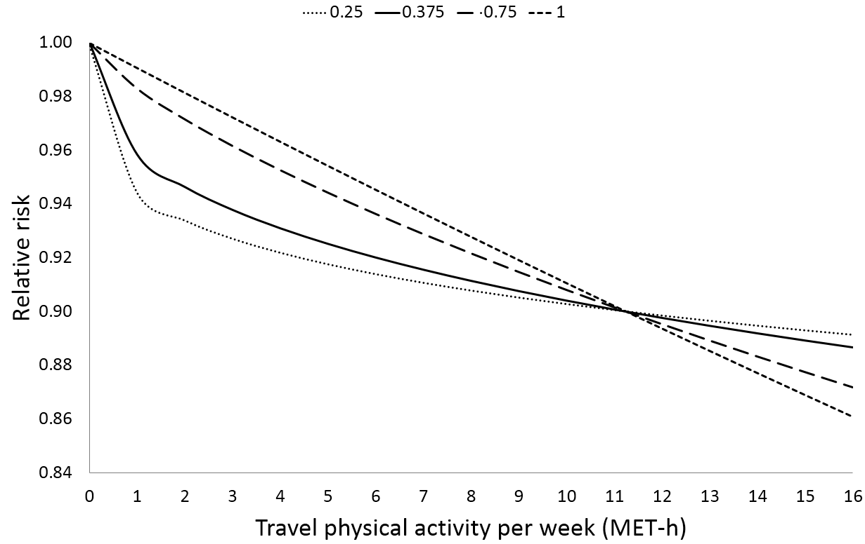
Figure 4: Dose-response relationship between weekly travel-based physical activity and all-cause mortality using four ways of exposure transformation

Integrated Injury and Physical Activity Model
For future scenarios, health burden from injuries and physical activity have been modelled using an integrated framework for the two risk factors. This was achieved using mode-specific travel time as exposure variable for injury modelling, which is the same exposure parameter used for modelling health impacts of physical activity. The mode-specific travel time is estimated using trip rate, sex-specific mode shares, and sex- and mode-specific average trip travel time. For modelling future scenarios, all parameters are assumed to be constant except the mode shares. The following sub-sections describe the injury model and the input parameters required by the model. The health impact estimates attributed to physical activity follow the same modelling framework as described in section 1.10, and the exposure input overlap with those of the injury model.

Injury Model
Baseline estimates of road traffic injuries were estimated using deaths data reported by the police department, and age-distribution and DALYs-to-deaths ratios provided by GBD – 2010. For future scenarios, with alternate travel scenarios, the number of fatalities have been modelled. Elvik (2009) reviewed studies reporting non-linear relationship between traffic volume or travel distance of travel modes on one hand and their corresponding injury risk on the other hand. The general form of the relationships reported in the literature is given as:
$$Number of accidents=αQ_{MV}^{β1}Q_{PED}^{β2}$$
In equation (20), Q_{MV} and Q_{PED} represent the exposure measure of motor vehicles and that of the pedestrians, respectively; α, β₁ and β₂ are the reported coefficients. The exposure measure can be mode-specific distance, volume, number of trips, or share of trips. According to the exponents of the exposure variable reported by Elvik from the review of literature, value of β is less than one for motor vehicles as well as for active travel modes. This implies that injury risk of pedestrians and cyclists are non-linearly related to their usage, with the former reducing as the latter increases.
Using the empirical relationship presented in equation above, Elvik (2009) proposed a model to carry out exploratory analysis of number of crashes resulting from hypothetical scenarios with varying traffic volume of motorised and non-motorised modes. In the model, crashes were classified into four types depending on the type of vehicles involved— a) multiple motor vehicles; b) single motor vehicle; c) pedestrian and motor vehicles; d) cyclists and motor vehicles. For this study, a modified version of the model has been used which uses travel time as the measure of exposure. Combining c) and d) into one term, the modified model can be expressed as shown in the following equation:
$$N=\sum_{i}{\sum_{j}{n_{i,j}×{\left[\frac{T_{i,f}}{T_{i,b}}\right]}^{∅_{mv}}×{\left[\frac{T_{j,f}}{T_{j,b}}\right]}^{∅_{mv}}}}+\sum_{i}{n_{i,0}×{\left[\frac{T_{i,f}}{T_{i,b}}\right]}^{∅_{mm}}}+\sum_{nm}{\sum_{j}{n_{nm,j}×{\left[\frac{T_{nm,f}}{T_{nm,b}}\right]}^{∅_{nm}}×{\left[\frac{T_{j,f}}{T_{j,b}}\right]}^{∅_{mv}}}}$$
where, i, j =motorised vehicle-user victim type (2W, car, bus, 3W, LDV, HDV); n_{i,j} = annual baseline fatalities involving multiple motorised vehicles; n_{i,0}= annual baseline single-vehicle fatalities of motorised vehicles; n_{nm,j} = pedestrian or cyclists fatalities with motorised vehicle as striking vehicle; f = future scenarios; b = baseline; T_{i} = annual travel time of trips using mode i; T_{nm,f} = annual travel time of walking or cycling trips; $∅_{mv}, ∅_{mm}, ∅_{nm}$ are the exponents for motorised vehicles crashes with multiple vehicles, single-vehicle motorised vehicle crashes, and non-motorised road-user crashes with motorised vehicles, respectively. The mode-specific travel time is estimated using the same fra for physical activity estimates, given as:
$$T_{i,b}=TR×P×S_{i}×\left[\left({G_{i,m}×TD}_{i,m}\right)+\left({G_{i,f}×TD}_{i,f}\right)\right]$$
where, TR= per capita trip rate, P = population older than 15 years, S_{i} = share of mode i, G_{i,m} and G_{i,m} are the sex-specific share of trips of mode i for males and females, respectively; and TD_{i} = average trip time of mode i. Since the model uses ratios of mode-specific travel time of the scenario to that of the baseline, the travel time does not need to be scaled up for annual estimate, as the scaling factor will be cancelled out by the division. Hence, daily travel time is used in the model. For HDV and LDV, travel time was not estimated and the three scenarios are considered as the following fractions—1, 0.5, and 0.25. This is because the model uses ratios of travel time.
Mode shift for future scenarios
For modelling alternate travel patterns, the adaptation from the baseline mode shares to the scenario mode shares has been done by keeping the total distance travelled by all modes constant between the baseline and the scenario. For example, if the baseline shares of trips are 5% for cycle and 45% for walk, and the scenario shares are 25% each, with all other modes retaining the same shares, then the additional 20% of cycle trips in the alternate scenario are accounted for by transferring 20% of the travel time of all baseline walking trips to cycling, after multiplying the travel time with the ratio of walking speed to that of cycling speed, so that the distance travelled remains the same. Mathematically, the example can be expressed as the two equations below, where TT_{walk,s} and TT_{cyc,s} are scenario travel time for walking and cycling, respectively:
$${TT}_{walk,s}=\frac{0.25}{0.45}×{TT}_{walk,b}$$
$${TT}_{cyc,s}=\left({TT}_{walk,b}×\frac{0.20}{0.45}×\frac{S_{walk}}{S_{cyc}}\right)+{TT}_{cyc,b}$$

where, TT_{walk,b} and TT_{cyc,b} are the baseline population travel time of walking (from walk as main mode) and cycling, respectively; S_{walk} and S_{cyc} are walking and cycling speed, respectively, estimated from travel diary data. In case when shift of travel time from one mode (say, walk) is done to more than one modes (say, 2W and Car), the travel time is distributed to the latter modes in proportion to their baseline mode share.
Stochastic framework
In order to account for the uncertainties in the estimates of travel characteristics, the health impact modelling for future scenarios have been done within a stochastic framework using Monte Carlo simulations. In this, the trip rates and baseline mode shares are not used as point estimates, but as distributions.

Victim and Striking-vehicle Matrix
For the model described above, n_{i,j} is an important input, which is the number of fatalities resulting in crashes involving different victim-type and striking-vehicle pairs. In the fatality data obtained from the police department, there were 39% of victims for which striking vehicles were not identified. This proportion varied significantly over different victim types; it was the highest for pedestrians (~50%), and was followed by 2W (~33%). Figure 5 presents diurnal trend of pedestrian fatalities with known and unknown striking-vehicle type. The share of unknown cases is higher during night-time and early morning hours— average of 57% of the total fatalities from 9 PM through 7 AM, and 40% otherwise. Since unknown striking-vehicle cases may largely be attributed to hit-and-run, they are more likely to be during night time than day time, which explains the diurnal variation.
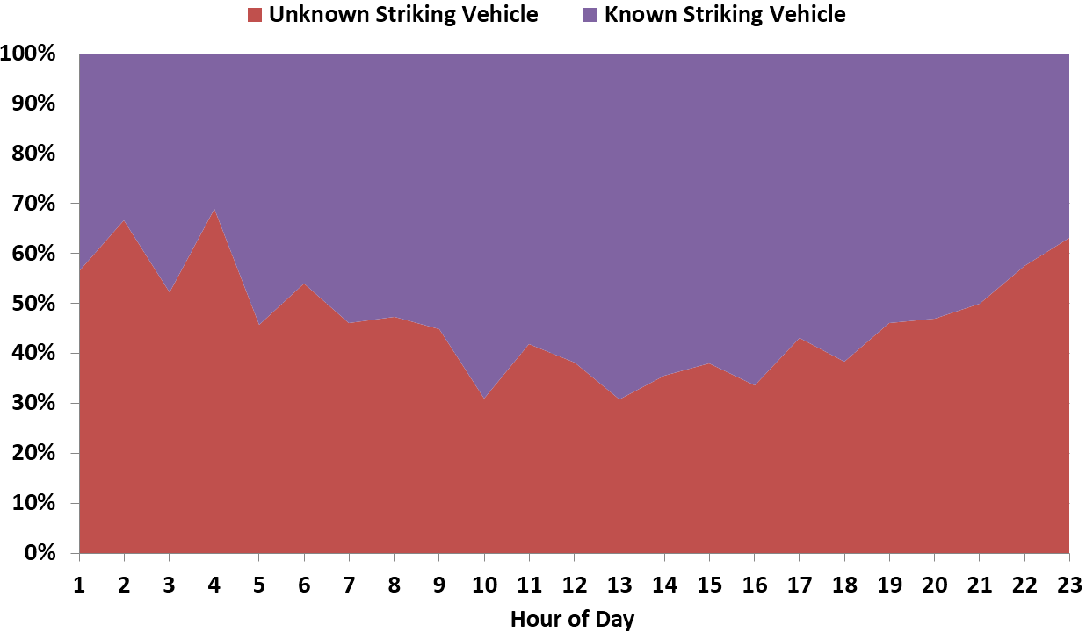
Figure 5: Time-of-day variation of share of known and unknown striking-vehicles involving pedestrian fatalities
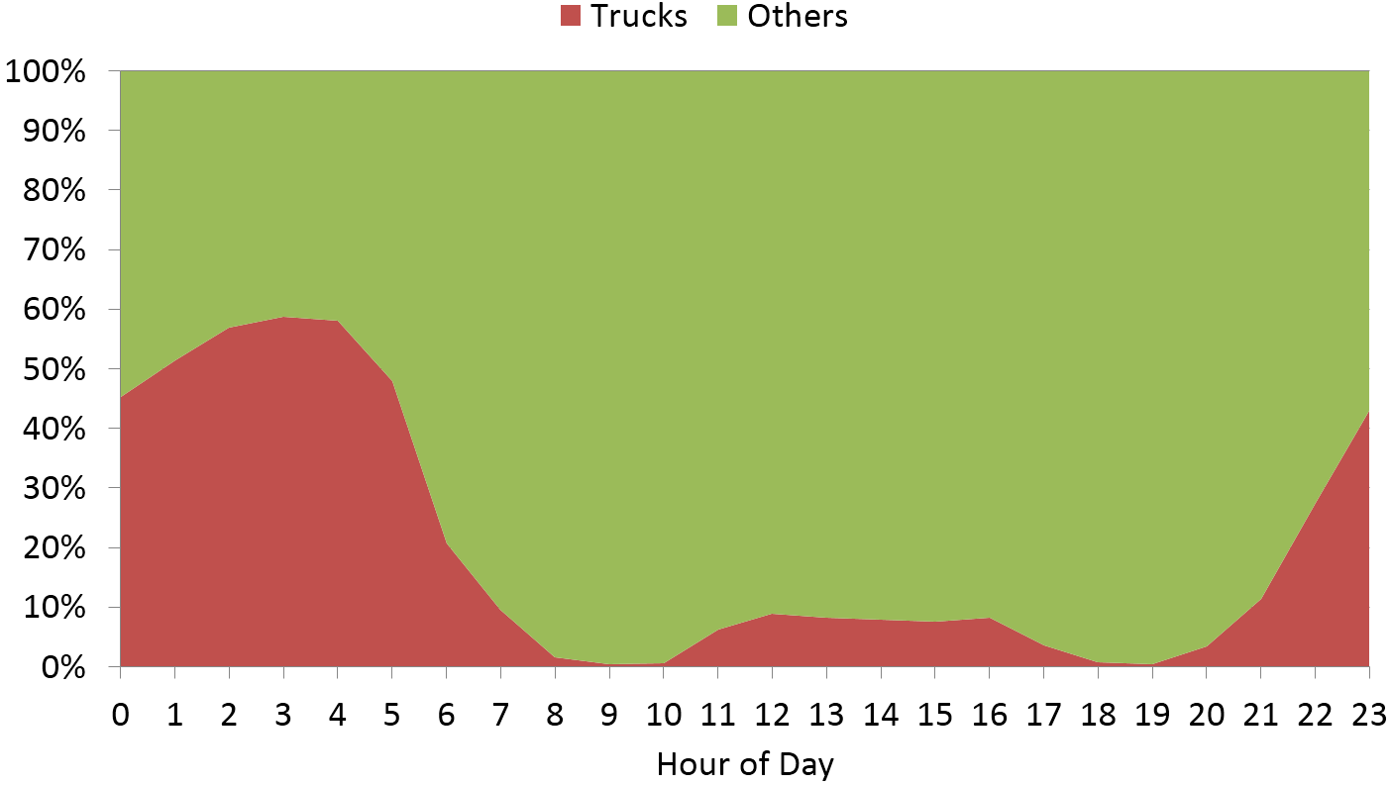
Figure 6: Diurnal variation of share of goods vehicles (LDV and HDV) and other motorised vehicles on Mathura road—a major arterial road in Delhi
In addition, the mode share of on-road motorised traffic also changes significantly over the day. For illustration, Figure 6 presents the diurnal trend of share of LDV and HDV among all the motorised vehicles, for a major arterial road (Mathura Road) in Delhi. Higher volume of trucks during night time is a result of the regulations imposed by the police department of Delhi, according to which day-time movement of HDV is prohibited on most roads within the city boundary (https://delhitrafficpolice.nic.in/about-us/notifications/). The two figures (Figures 5 and 6) show that higher proportion of unknown cases coincide with the time of day when proportion of goods vehicles is also high.
In order to control for the variation of on-road traffic mix, known striking-vehicle cases were classified into two time periods— a) night time (9PM through 7AM) and b) day time (rest of the day)—based on the share of goods vehicles in on-road traffic mix (Figure 6). There were 10% of the cases with no reported time-of-occurrence of the crashes. These cases were distributed among day and night in the same proportion as the cases with known time-of-occurrence, classified by victim type. Figure 7 presents distribution of striking vehicles for known cases of pedestrian fatalities, classified by time-of-day. The most significant difference occurs between buses and heavy trucks. During the night time, share of buses is less than half their share during the day. Heavy trucks, on the other hand, have much higher share during night time. This is expected as, during night time, the operation of city-based buses is limited while that of trucks increases.
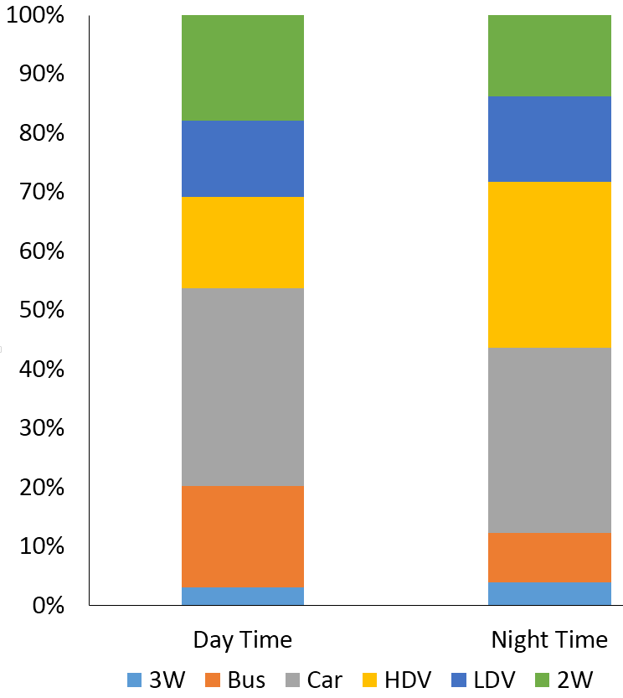
Figure 7: Time-of-day-specific distribution of striking vehicles in pedestrian deaths for crashes with known striking vehicles
From the known striking-vehicle cases, victim- and time-of-day-specific (day or night) distribution of striking vehicles was calculated. This distribution was then used with victim- and time-of-day-specific fatalities for unknown striking-vehicle cases. Next, the data was aggregated, and the resulting matrix of striking vehicles and victims is shown in Table 6. In the table, fatalities are the average for the period 2010 through 2012.
According to the matrix, in Delhi, up to 50% of the pedestrian fatalities are estimated to be caused in crashes involving heavy vehicles—buses, LDV and HDV, and one-third are caused in crashes involving cars. In case of cycles, more than 60% fatalities are caused in crashes involving heavy vehicles, and cars have one-fourth of the share. In case of cars and 2W, at least a quarter of the fatalities are reported to have occurred in single-vehicle crashes. In contrast, there are no fatal cases reported for single-vehicle crashes of pedestrians and cyclists. For modelling of fatalities for alternate future scenarios, fatal cases from cycle rickshaw and NMT goods were not considered, with a combined share of total fatalities less than 2%. In total, 38% of the fatalities occur with trucks as striking vehicles, 37% with 2W and cars, and 17% with buses and other PT modes.
Table 6: Matrix of victim road-user type and striking vehicles (expressed as percent of total fatalities within each victim category)
 | Victim road-user type (% of column total)
Striking Vehicle | Pedestrian | Cycle | 2W | Car | Bus | 3W | Cycle Rickshaw | HDV | LDV | NMT Goods | All
Self | 0 | 0 | 13 | 33 | 10 | 27 | 0 | 41 | 47 | 0 | 8
2W | 16 | 9 | 4 | 2 | 2 | 1 | 20 | 2 | 1 | 0 | 10
Car | 33 | 26 | 24 | 20 | 5 | 26 | 32 | 13 | 9 | 26 | 27
3W | 3 | 3 | 2 | 1 | 1 | 5 | 1 | 2 | 1 | 0 | 3
Bus | 13 | 17 | 14 | 7 | 78 | 7 | 15 | 5 | 1 | 8 | 14
LDV | 14 | 17 | 13 | 13 | 1 | 12 | 9 | 10 | 14 | 40 | 13
HDV | 21 | 29 | 30 | 24 | 3 | 21 | 22 | 27 | 27 | 26 | 25
Total (%) | 100 | 100 | 100 | 100 | 100 | 100 | 100 | 100 | 100 | 100 | 100
Total (n) | 906 | 118 | 688 | 110 | 31 | 48 | 28 | 21 | 35 | 5 | 1990

PM_{2.5} Dispersion Modelling
For dispersion modelling, Atmospheric Transport Modelling System (ATMoS) dispersion model was used, which is a regional (and urban) forward trajectory Lagrangian Puff-transport model (Calori and Carmichael, 1999). This version is modified from the US National Oceanic Atmospheric Administration, Branch Atmospheric Trajectory (BAT) model (Heffter, 1983). Input meteorological data (3D wind, temperature, and pressure, as well as surface heat flux and precipitation fields) is derived from the National Center for Environmental Prediction (NCEP) global reanalysis (NCEP, 2012) and interpolated to the model grid. The mixing heights are as high as 2500 meters during the summer days and as low as 50 meters during the winter nights. The layers include a surface layer, boundary layer (designated as the mixing layer height) and a top reservoir layer. The multiple layers allow the model to differentiate the contributions of sources varying in their elevation from the ground. The dispersion model was validated by comparing modelled monthly concentrations with those reported by six air quality monitoring stations in Delhi, in a previous study (see Figure 8; Guttikunda and Calori, 2013)
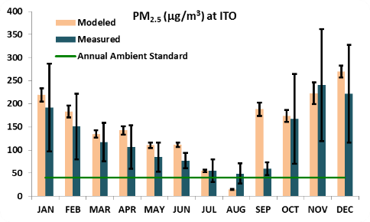 | 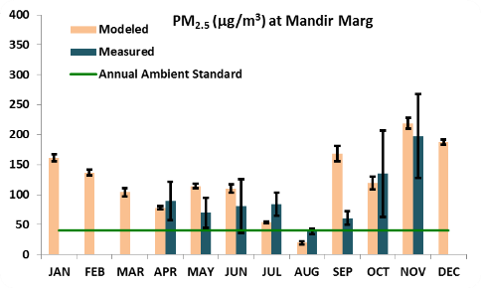 | 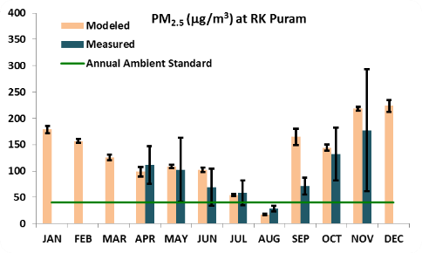
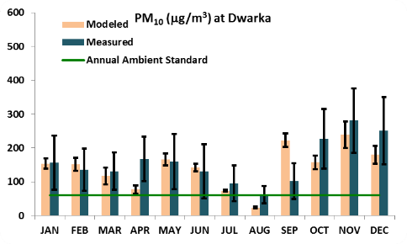 | 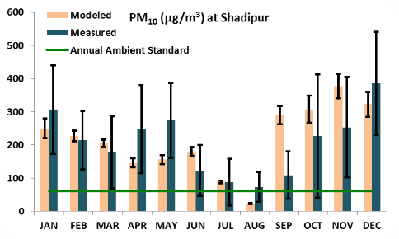 | 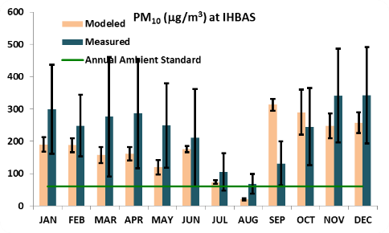
Figure 8: Comparison of modelled and measured PM_{2.5} and PM₁₀ concentrations for the base year 2010 in Delhi, India (Guttikunda and Calori, 2013)
For this study four different source-types were used— a) near-ground diffused area-sources (domestic sector, waste burning, construction, diesel gensets); b) vehicle sources (vehicular exhaust and road dust); c) small-point sources (industries, brick kilns); and d) large-point sources such as power plant stacks. In addition to primary PM_{2.5}, the model also includes first order chemical reactions for SO₂ and NO_{x} emissions to estimate the secondary contributions in the form of sulphates and nitrates, added to the total PM_{2.5} concentrations.
Using the model, source-receptor transfer matrices (SRTM) were generated. The SRTMs enable the conversion of emissions to concentrations and represent the change in concentrations in a receptor grid per unit change in annual emissions in the source grid. For a model domain of size 80×80 grids, SRTM is a square matrix with 6400 rows and as many columns. For each row i, SRTM gives concentration increase in each of the 6400 grids, for a unit increase in the emissions of grid i. The product of SRTMs and emission matrices give gridded concentrations (µg/m³) for the whole domain. For 80 km×80 km domain of Delhi and a grid resolution of 1km×1km, emission matrix is 6400×1 and SRTM is 6400×6400. For 3 pollutants (PM_{2.5}, NO_{x} and SO₂) classified among 4 source-types, there are 12 emission matrices and 12 corresponding SRTMs, which were multiplied pair-wise, and then added to obtain overall modelled concentrations. See equation 6 for calculation of modelled concentration of a grid for domain size of 80×80 grids, and SRTM and emission matrices classified among 4 layers and 3 pollutant types.
$${CM}_{ij}=\sum_{p=1}^{3}{\sum_{k=1}^{4}{\sum_{l=1}^{6400}{{CU}_{ij,l,k,p}\frac{E_{ij,l,k,p}}{E_{b}}}}}$$ | (6)
where, ij refers to the grid at row i and column j of the model domain; k refers to the layer type, p refers to the pollutant type, l refers to the grid number, ${CM}_{ij}$ refers to the modelled concentration at grid ij; CU is the concentration increase corresponding to pollutant- and layer-specific constant emissions of $E_{b}$ (=100 tonnes) in grid ij.
The modelling setup was done in MATLAB (Mathworks, Inc., Natick, MA) computing platform. Using multiple iterations, emission inventory was calibrated by comparing the modelled concentrations with the annual-average concentration of three air-quality monitoring stations operated by DPCC. The data of the three stations have been presented in Figure 9 and their geographic locations are shown in Figure 10. Using these, gridded annual-average modelled PM_{2.5} concentrations were obtained. To estimate the contribution of transport sector to total modelled concentration in each grid, we used the following calculation:
$$f_{veh,ij}=\frac{\sum_{p=1}^{3}{\sum_{l=1}^{6400}{{CU}_{ij,l,veh,p}\frac{E_{ij,l,veh,p}}{E_{b}}}}}{{CM}_{ij}}$$ | (7)

To estimate city-wide population-weighted average contribution of transport to overall pollution ($f_{veh, city}$), we used the following calculation:
$$f_{veh, city} =P_{ij}\frac{f_{veh,ij}}{\sum_{ij}{P_{ij}}}∀ ij∈D$$ | (8)
where, D is the set of row and column combination of grids covering Delhi, and $P_{ij}$ is the population of grid $ij$. Note that the modelling domain for dispersion model consists of Delhi as well as its neighbouring cities. However, for the purpose of health impact estimates, only Delhi has been considered as the case study. Using similar method, the city-level average shares of other three sectors were also estimated.

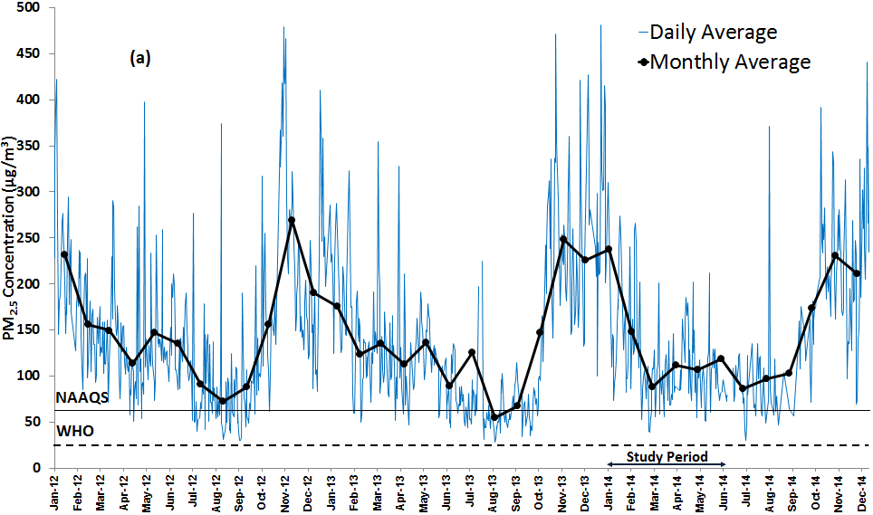
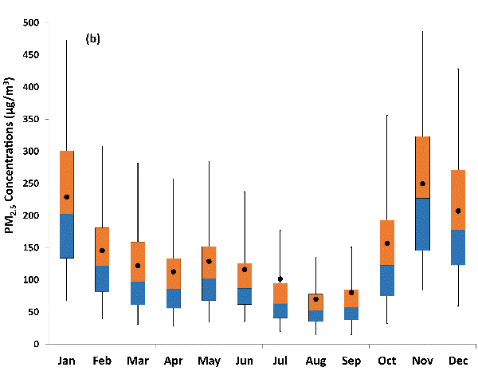 | 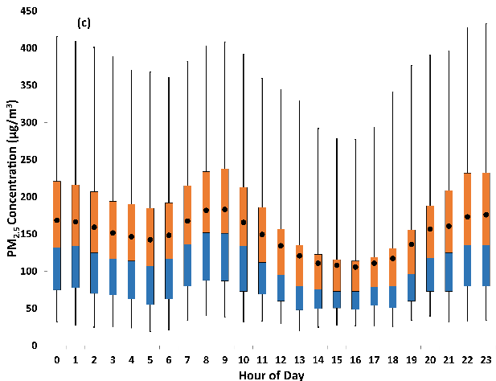
Figure 9: (a) Daily and monthly average PM_{2.5} concentrations between Jan’12 and Dec’14 (b) Monthly variation in PM_{2.5} concentrations in 2012, 2013, and 2014 (c) Diurnal variation in PM_{2.5} concentrations in 2012, 2013, and 2014. For (b) and (c), the dot represents the mean; box plot represents 25th and 75th percentile, with median at the break; and whiskers represent the 5th and 95th percentile
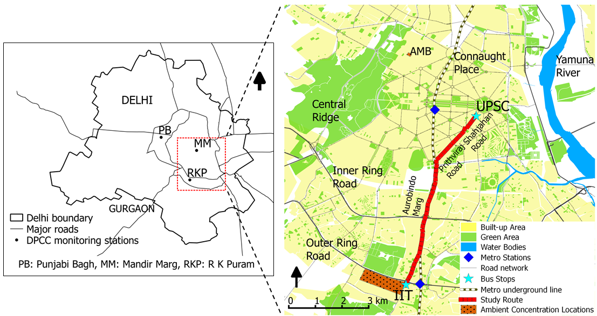
Figure 10: DPCC ambient air quality monitoring stations and on-road pollution exposure study route used in Goel et al. (2015)

Multi-Pollutant Emission Inventory
Table 7 presents multi-pollutant annual emission inventory for 2014, classified by different sectors. PM_{2.5} emissions are contributed by several sectors, with no single sector as a major contributor. Vehicles, industries, brick kilns, gensets, waste burning, and power plants, have a share of more than 10%. SO₂ emissions from vehicles is only 2%, which is due to the reduction of fuel sulphur content over time. Vehicles are a major contributor of NO_{x} as well as VOC emissions, contributing more than one-third and more than one-fourth of total emissions, respectively.
Table 7: Total and Sector-specific Shares of Emissions for Year 2014
Sector | PM_{2.5} | PM₁₀ | SO₂ | NO_{x} | CO | VOC
Vehicular Exhaust | 15% | 10% | 2% | 35% | 18% | 26%
Road Dust | 8% | 18% | - | - | - | -
Domestic | 7% | 5% | 4% | 0% | 8% | 5%
Gensets | 11% | 9% | 1% | 44% | 13% | 33%
Brick Kilns | 16% | 13% | 15% | 2% | 15% | 13%
Industries | 15% | 13% | 29% | 11% | 17% | 7%
Construction | 6% | 12% | 0% | 1% | 0% | 0%
Waste Burning | 11% | 9% | 1% | 1% | 4% | 3%
Power Plants | 11% | 12% | 47% | 6% | 24% | 12%
Total (%) | 100% | 100% | 100% | 100% | 100% | 100%
Total (tonnes) | 84,000 | 138,000 | 40,500 | 517,000 | 1,770,600 | 269,000
Figure 11 presents gridded vehicular-exhaust and road-dust PM_{2.5} emissions, obtained using GIS-based and other secondary data resources. Highest levels of emissions are within the core area of the city as well as the ring roads. This is because this road network coincides with high-density population settlement in the city (see Figure 12). The two ring roads also have high freight vehicle movement serving as important links for various radial highways. The highways have high emissions due to inter-city buses as well as freight movement, while the movement of cars and 2W is less on those roads compared to the core city.
Figure 11: Gridded Vehicular-Exhaust and Road-Dust PM_{2.5} Annual Emissions
- Gridded population density | - Annual-average PM_{2.5} concentrations
Figure 12: Gridded population and modelled PM_{2.5} concentrations for Delhi (80km×80km domain)
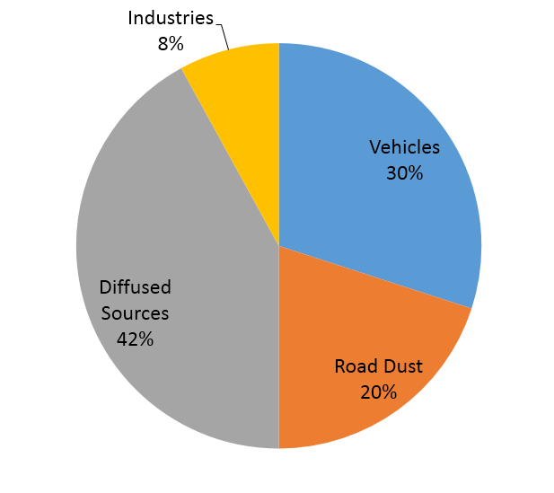 | 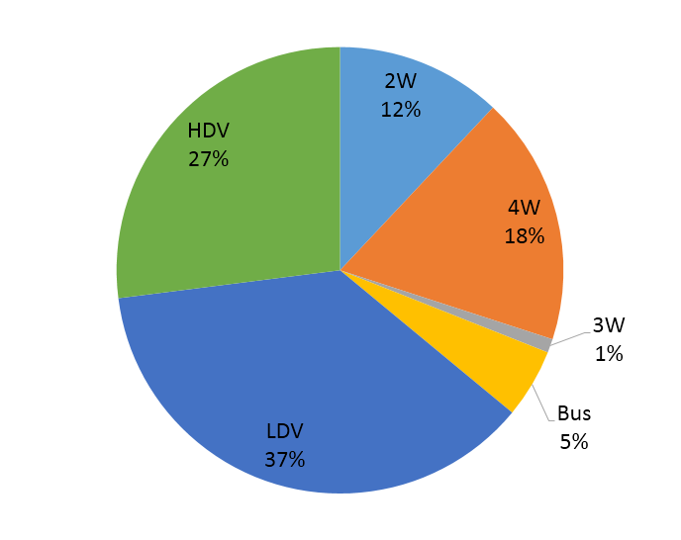
- Population-weighted sectoral distribution of ambient PM_{2.5} concentrations | - Distribution of vehicular exhaust PM_{2.5} emissions/pollution among different vehicle types
Diffused sources—waste burning, household cooking, construction, diesel generator sets; industries— industries, brick kilns, and power plants
Figure 13: Sectoral distribution of ambient PM_{2.5} concentrations and distribution of vehicular-exhaust PM_{2.5} among different vehicle types

Spatial Distribution and Sector-specific Shares of PM_{2.5} Concentrations

Static Approach
The annual-average modelled PM_{2.5} concentration and the gridded population is presented in Figure 3-6. By superimposing the two layers, the population-weighted PM_{2.5} concentration in Delhi has been estimated as 83 µg/m³. Population-weighted average contribution from vehicular exhaust is 30% and from dust re-suspension is 20% (see Figure 13 (a)). Up to half the population is exposed to concentrations with vehicular exhaust contributing 30% or less, and the maximum contribution of vehicular exhaust is 45%.
Assuming that vehicle-specific shares of vehicular-exhaust pollution are similar to respective shares in the PM_{2.5} pollution, the distribution of PM_{2.5} pollution from vehicular exhaust among different vehicle types is shown in Figure 13 (b). The sector-specific share in pollution and vehicle-specific share in emissions can be used to estimate vehicle-specific share of PM_{2.5} pollution. For a 36% share of passenger transport modes (2W, 4W, 3W, bus) among vehicular-exhaust emissions, and a 30% share of vehicular-exhaust in ambient PM_{2.5} pollution, 11% (36%×30%) of total PM_{2.5} pollution is contributed by vehicular exhaust from passenger vehicles (2W, 4W, 3W, bus) and 19% from goods vehicles.
Figure 14: Spatial mapping of population superimposed over spatial distribution of PM2.5 pollution

Dynamic Approach
Figure 14 shows within-day spatial movement of population (sampled individuals) superimposed over spatial distribution of PM_{2.5} pollution. The trip destinations shown in the figure includes entire-day activity locations visited by all the individuals in the sample who reported a trip. The figure also shows the residential localities of the sampled population, highlighting the difference between a static and dynamic approach; the former assumes that individuals spend the entire day at their home location. Using dynamic approach, when spatio-temporal movement of population is taken into account, average PM_{2.5} concentration is 81µg/m³. Comparing the static estimate with the dynamic estimate, the two differ by 2 µg/m³, which is 2.5% of the static estimate. Thus, the dynamic and static assessment are similar.
To assess the effect of mode of travel on average PM_{2.5} exposure of the population, the dynamic approach was modified, it was assumed that the mode of travel did not make any difference on the exposure and in-vehicle concentrations are equal to that of ambient locations, which effectively means that $Ƴ$ =1 for all modes. We refer to this as modified dynamic approach. The average PM_{2.5} concentration is estimated to be 78 µg/m³ for modified approach which differs from dynamic approach by 3 µg/m³ (see Table 8). Clearly, at the population level, on-road travel makes a difference of less than 4% in pollution exposure.
Table 8: Different Approaches to Estimate Population Exposure to PM_{2.5} Pollution
Approach | Description | Population-average PM_{2.5} exposure
Static Approach | Assumes that population is static at their residential location throughout the day | 83 µg/m³
Dynamic Approach | Accounts for within-day movement of individuals from one location to another and higher exposure during on-road travel | 81µg/m³
Modified Dynamic Approach | Accounts for within-day movement of individuals from one location to another, however, assumes that exposure during travel is same as in ambient location | 78 µg/m³
To assess the difference in pollution exposure of individuals due to their income and mode of travel, the individuals were classified based on their household vehicle ownership. This is because income of households is not known and vehicle ownership of the household is a good indicator for mode of travel as well as income level. The households were divided into three categories—a) those owning at least one car, b) those owning at least one 2W and no car, and c) and those owning no car or 2W (see Table 9). Next, we estimate the pollution for the three population groups using static as well as dynamic approach, the former assumes all exposure at residential location, while the latter accounts for within-day movement and on-road exposure.
PM2_{.5} exposure using static approach is significantly higher for car owning households than the other two groups. Since static approach assumes exposure only at the residential location, it implies that car owning households live in the core of the city where pollution is the highest, while the other two groups live in cleaner locations away from the core of the city. The spatial distribution of different income groups can also be seen through the map of property rate presented in Figure. The map clearly shows that there is a general trend of reducing property rates as one moves towards to the periphery of the city.
Table 9: Population Exposure to PM_{2.5} Pollution for Population Groups Classified by Vehicle Ownership
Vehicle ownership of households | Population-average PM_{2.5} exposure
 | Dynamic Approach | Static Approach
Car | 98 µg/m³ | 97 µg/m³
2W | 82 µg/m³ | 78 µg/m³
Cycle or none | 79 µg/m³ | 74 µg/m³
Comparing the dynamic approach assessment of PM_{2.5} with static approach for the three population groups, estimate of dynamic approach is highly correlated to estimate of static approach. This indicates that where people live has an important implication on their overall-day pollution exposure. It can also be observed that the difference between static and dynamic approach is a function of vehicle ownership. For car-owning households the two estimates are almost similar, while for the other two population groups, the estimate using dynamic approach is higher than static approach by 5 to 6%. This is possible due to two reasons. Firstly, the two categories of households not owning a car, have higher exposure during their travel, as a result dynamic approach estimate is higher than static estimate. Secondly, the individuals in these households though live in cleaner locations, travel to locations with higher pollution during the day.
In general, more than 95% of the pollution exposure can be explained by residential location alone. This is possible because, for a 24-hour period, individuals spend less than an hour for on-road travel. Therefore, 96% (1/24) of their 24-hour duration is in locations away from road. Also, more than 60% of the trips are less than 3 km long. Thus, most individuals spend their out-of-home duration in locations close to their residences, and therefore, the pollution exposure at the two locations will be similar.

UNCERTAINTY ANALYSIS OF HEALTH BURDEN ESTIMATES
Due to small sample size for household travel survey, a considerable uncertainty remains in the estimates of travel characteristics—mode shares, trip distance, trip travel time, and trip rates. In addition, large uncertainties occur in estimates of bottom-up emission inventories (transport as well as non-transport sectors), pollution estimates using dispersion modelling, and sector-specific shares in overall concentrations. In order to address the uncertainties in these parameters and the resulting uncertainty in the estimates of health outcomes, Monte Carlo simulations (MCS) have been used. The uncertainty analysis has been done for health burden from physical activity and air pollution. The baseline injury burden has been estimated from the police-reported data and, therefore, has no parametric uncertainty.
In the MCS analysis, single-point estimates of parameters are replaced by their probability distributions. The distributions vary depending on the extent of uncertainty and the spread of parameter values, which are dependent on prior information of the parameter from previous literature or expert opinion. For instance, a uniform distribution represents complete uncertainty about a parameter, and gives equal probability of selection to all values within the range. Triangular and normal distributions, on other hand, give higher probability of selection to certain values, denoted by their peaks, than the others. The MCS analysis consists of a number of iterations to estimate the output, and in each iteration, values of different parameters are randomly generated from their corresponding distribution functions. A series of iterations results in a distribution of an output value, in contrast to a single-point estimate if deterministic values of each input parameter was used.
For this analysis, 10,000 iterations were used and the simulation setup was done in Microsoft Excel spreadsheet program. A total of 11 parameters were selected for uncertainty analysis, and were expressed as various types of distributions— uniform, triangular, or normal, presented in Table 10. The table also gives explanation for selecting the distribution parameters. For illustration, Figure 15 (a) and (b) present triangular distribution of per-capita trip-rate values and normal distribution of PM_{2.5} dose-response coefficient.
Table 10: Parameters used for uncertainty analysis
Parameter | Uncertainty Distribution |  | Description and references
Trip rate per capita per day | Triangular distribution  (min – 1.4, mode – 1.5, max – 2) |  | To account for underreporting of trips settings 1.4 – estimated in this study;  With high share of non-motorised modes and public transport – Singapore and Japan, have 2 trips per capita; 1.5 – author’s judgment (Schafer, 2000; LTA, 2012)
Walking mode share (%) | Triangular distribution  (35, 42, 47) |  | For addressing variability of mode share; 35% mode share of walk reported in 2007 survey by RITES; 42% this study; shares of the rest of the modes are calculated in proportion to their share within non-walk mode
Scaling of daily physical activity to weekly physical activity | Triangular distribution  (1, 1.2, 1.4) |  | 1 – indicates no travel physical-activity during weekend; 1.2 – indicates 50% of weekday activity during weekend, reported by Hankey et al. (2012); 1.4 indicates the travel physical activity remains constant across all days
Transformation parameter (t) of physical activity exposure | Triangular distribution  (0.25, 0.5, 1) |  | Non-linearity of physical-activity exposure: linear (1), square root (0.5) and power (0.25) transformation of exposure (Woodcock et al., 2011; Kelly et al., 2014)
Relative risk for physical activity | Normal distribution  (mean, standard deviation)  All-cause mortality: 0.9 (0.02); cardiovascular diseases: 0.84 (0.03); type-II diabetes: 0.83 (0.04) |  | Using 95% CI of the coefficients (see sources in Table 2-11)
Relative risk for PM_{2.5} pollution | Using GEMM function for non-communicable disease plus lower respiratory infection reported by Burnett et al. (2018) |  | Using 95% CI of the coefficients
Counterfactual for PM_{2.5} concentration (µg/m³) | Uniform Distribution  (min, max): (5.8, 8.8) |  | Range used by GBD-2010; Burnett et al. (2014)
Annual average PM_{2.5} concentration (µg/m³) | Triangular distribution  (80, 85, 100) |  | Minimum: estimated in this study; mode and max – author’s judgment to account for the difference between modelled concentrations and reported concentrations at the three monitoring stations
Share of vehicular exhaust to PM_{2.5} concentration (%) | Triangular distribution  (20, 25, 30) |  | Pant et al. (2015) estimated share of vehicular exhaust – 16-19% (only primary emissions)  This study – 30% (both primary and secondary);  25% – author’s judgment
Exponent for non-motorised modes in injury model | Triangular distribution  (0.3, 0.5, 0.7) |  | Median, 5th and 95th percentile values reported in Elvik (2009)
Exponent for motorised modes in injury model | Triangular distribution  (0.1, 0.5, 1) |  | Median, 5th and 95th percentile values reported in Elvik (2009)
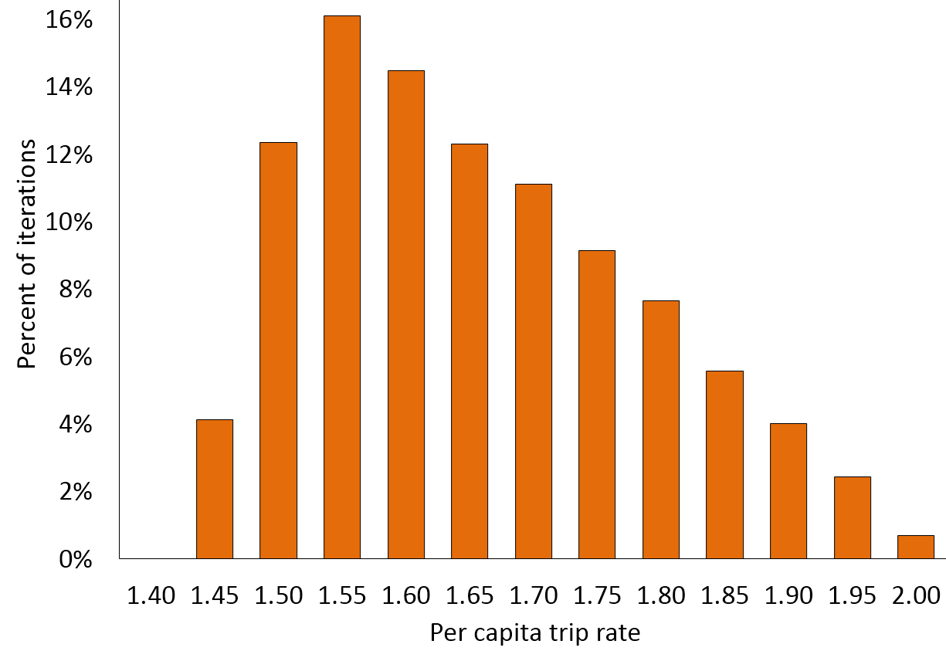 |  | 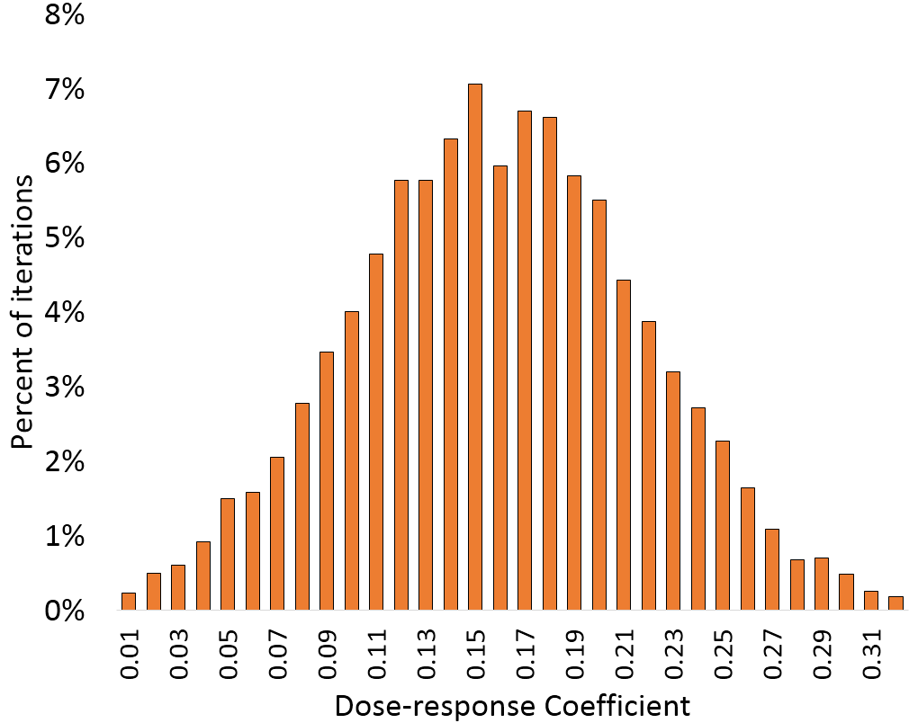
- Triangular distribution of per-capita trip-rate |  | - Normal distribution of PM_{2.5} dose-response coefficient of cardio-respiratory diseases
Figure 15: Examples of probability distributions of the input parameters used for uncertainty analysis
Figure 16 presents distribution of all-cause mortality estimates due to physical activity and air pollution, using 10,000 iterations of MCS analysis.

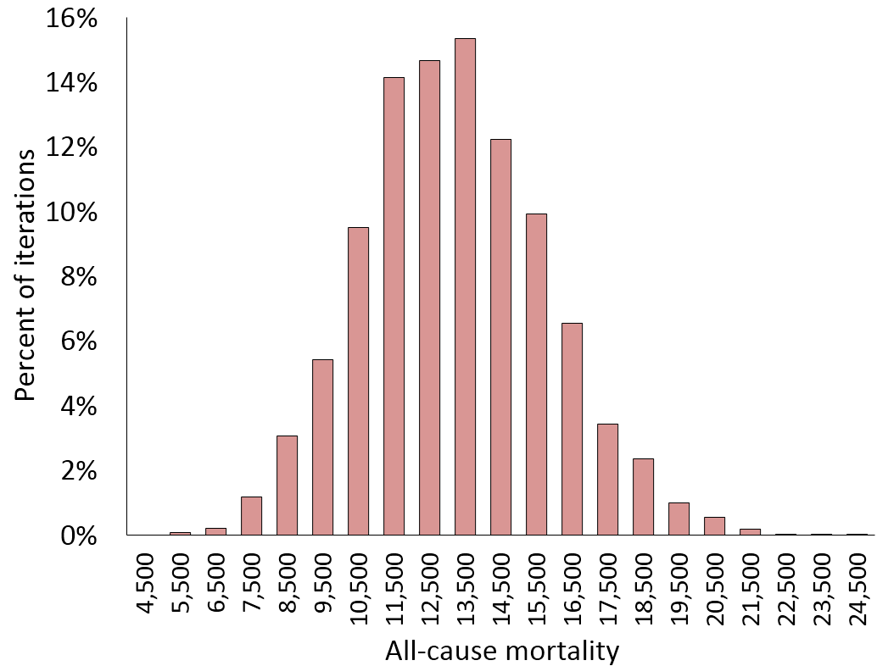 | 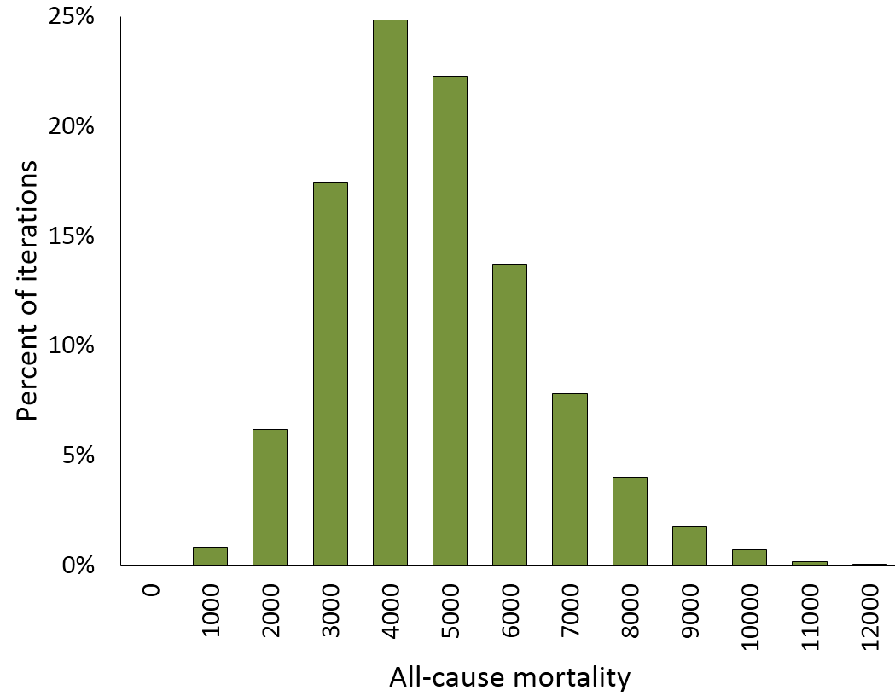
- Physical activity | - PM_{2.5} pollution from road transport
Figure 16: Distribution of all-cause mortality estimated using 10,000 Monte Carlo simulation iterations
In order to understand the importance of different parameters (Table 10) in determining all-cause mortality estimates, Spearman’s rank-order correlation was calculated between each of the parameters and all-cause mortality, for physical activity and PM_{2.5} pollution (see Figure 17). The Spearman correlation coefficient is defined as the Pearson correlation coefficient between the ranked variables. For physical activity as well as PM_{2.5} pollution, the dose-response-function related parameters are the main variables affecting all-cause mortality. Among, travel-behaviour related parameters, mode share of walking has minimal effect and trip rate and scaling parameter for weekend travel activity are equally more important. In PM_{2.5} pollution, percent share of transport is also an important parameter affecting the estimate of mortality.
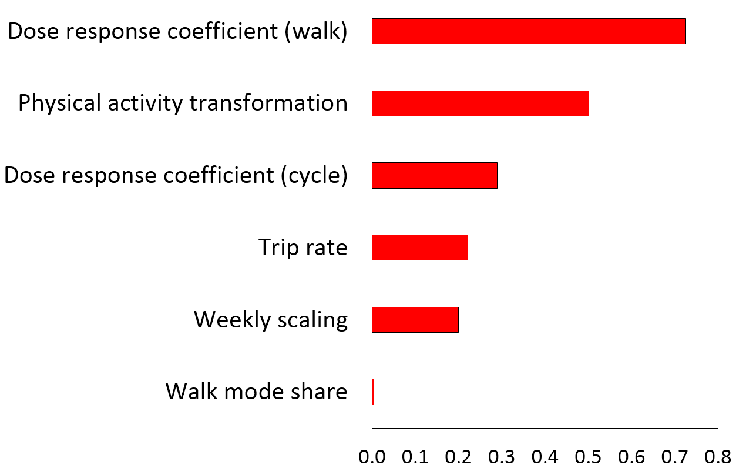 | 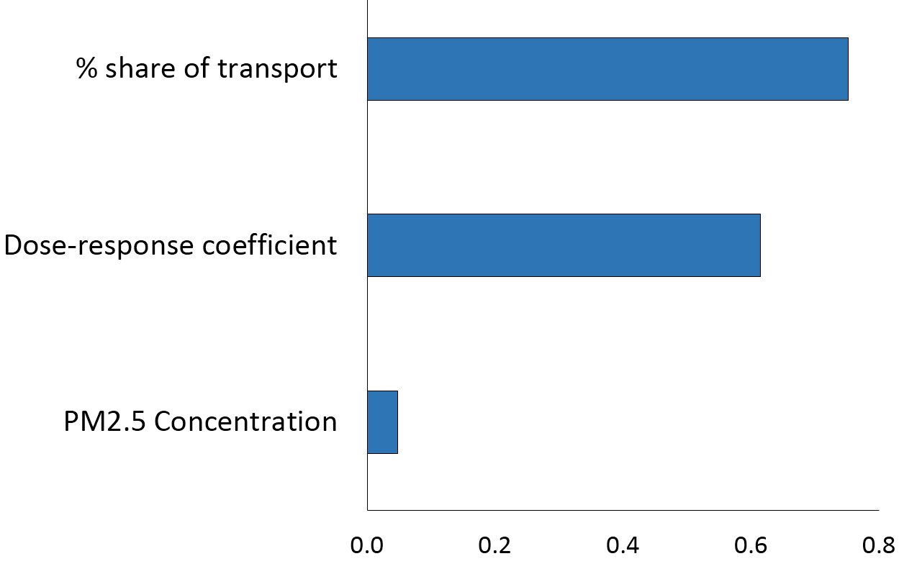
- Physical activity | - PM_{2.5} Pollution
Figure 17: Spearman’s rank-correlation between input parameters and all-cause mortality estimates

REFERENCES
Angel, S., Parent, J., Civco, D. L., & Blei, A. M. (2010). The persistent decline in urban densities: Global and historical evidence of sprawl. Lincoln Institute of Land Policy Working Paper.
Burnett, R. et al. (2018) ‘Global estimates of mortality associated with longterm exposure to outdoor fine particulate matter’, Proceedings of the National Academy of Sciences of the United States of America, 115(38), pp. 9592–9597.
Calori, G., & Carmichael, G. R. (1999). An urban trajectory model for sulphur in Asian megacities: model concepts and preliminary application. Atmospheric Environment, 33(19), 3109-3117.
Census-India (2012). Census of India, 2011. The Government of India, New Delhi, India.
Elvik, R. (2009). The non-linearity of risk and the promotion of environmentally sustainable transport, Accident Analysis & Prevention, vol. 41, no. 4, pp. 849-855.
Ezzati, M. (Ed.) (2004). Physical inactivity. Comparative Quantification of Health Risks Global and Regional Burden of Disease Attributable to Selected Major Risk Factors. Geneva: World Health Organization, 729-881.
Goel, R., Gani, S., et al. (2015) ‘On-road PM2.5 pollution exposure in multiple transport microenvironments in Delhi’, Atmospheric Environment. Elsevier Ltd, 123, pp. 129–138.
Götschi, T. et al. (2015) ‘Contrasts in active transport behaviour across four countries: How do they translate into public health benefits?’, Preventive medicine. Elsevier, 74, pp. 42–48.
Guttikunda, S. K. & Calori, G. (2013). A GIS based emissions inventory at 1 km × 1 km spatial resolution for air pollution analysis in Delhi, India. Atmospheric Environment, 67, 101-111.
Hamer, M., & Chida, Y. (2008). Active commuting and cardiovascular risk: a meta-analytic review. Preventive medicine, 46(1), 9-13.
Harriss, D. J., Greg Atkinson, A. Batterham, K. George, N. Tim Cable, Thomas Reilly, Najib Haboubi, Andrew G. Renehan, and Colorectal Cancer, Lifestyle, Exercise And Research Group. "Lifestyle factors and colorectal cancer risk (2): a systematic review and meta‐analysis of associations with leisure‐time physical activity." Colorectal Disease 11, no. 7 (2009): 689-701.
Heffter, J.L. (1983). Branching Atmospheric Trajectory (BAT) Model, NOAA Tech. Memo. ERL ARL-121 Air Resources Laboratory, Rockville, MD USA (1983)
Jeon, C. Y., Lokken, R. P., Hu, F. B., & Van Dam, R. M. (2007). Physical Activity of Moderate Intensity and Risk of Type 2 Diabetes A systematic review. Diabetes care, 30(3), 744-752.
Kelly, P., Kahlmeier, S., Götschi, T., Orsini, N., Richards, J., Roberts, N., ..& Foster, C. (2014). Systematic review and meta-analysis of reduction in all-cause mortality from walking and cycling and shape of dose response relationship. Int. J. Behav Nutr. Phys. Activ, 11.
Monninkhof, E. M., Elias, S. G., Vlems, F. A., van der Tweel, I., Schuit, A. J., Voskuil, D. W., & van Leeuwen, F. E. (2007). Physical activity and breast cancer: a systematic review. Epidemiology, 137-157.
NCEP (2012). National Centers for Environmental Prediction. National Oceanic and Atmospheric Administration, Maryland, USA (2012)
Paffenbarger Jr, R. S., Lee, I. M., & Leung, R. (1994). Physical activity and personal characteristics associated with depression and suicide in American college men. Acta Psychiatrica Scandinavica, 89, 16-22.
Woodcock, J., Franco, O. H., Orsini, N., & Roberts, I. (2011). Non-vigorous physical activity and all-cause mortality: systematic review and meta-analysis of cohort studies. International Journal of Epidemiology, 40(1), 121-138.

